**Windows Subsystem for Linux**” (**WSL**)

**Introduction**

Windows Subsystem for Linux (WSL) is a compatibility layer for running Linux binary executable natively on Windows 10. WSL allows users to run Linux distributions on Windows 10 without needing to create a virtual machine. WSL also provides an environment for developing Linux applications on Windows. WSL makes it possible to run Bash shell scripts, Linux command-line tools, and other Linux applications directly on Windows 10.

**Bash and .sh file in Linux:**

Bash is a Unix shell and command language used in Linux and other Unix-like operating systems. Bash is the default shell on most Linux distributions, and it's used to interpret commands that are typed into a command-line interface. Bash allows users to execute commands, manipulate files and directories, and run shell scripts. A Bash script is a text file that contains a series of commands that are executed in sequence. A Bash file typically has a .sh extension.

**How to Setup WSL on Windows?**

**Step 01: Go to windows setup > setting and open**

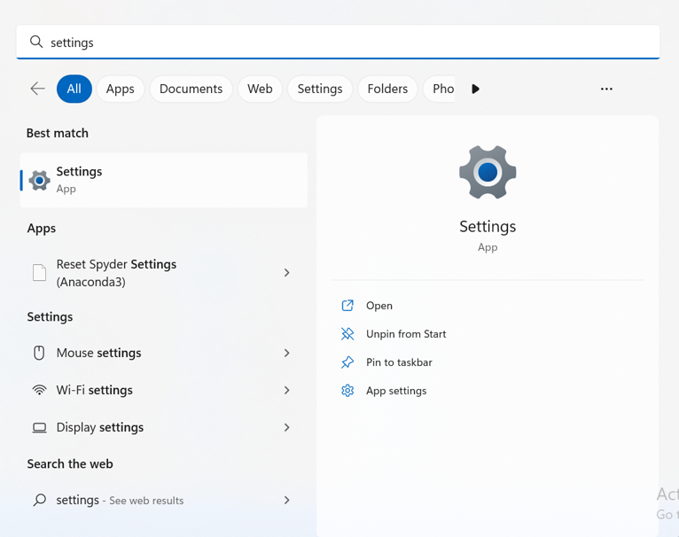

**Step 02: Go to Privacy & Security> For developers and turn on developer option**

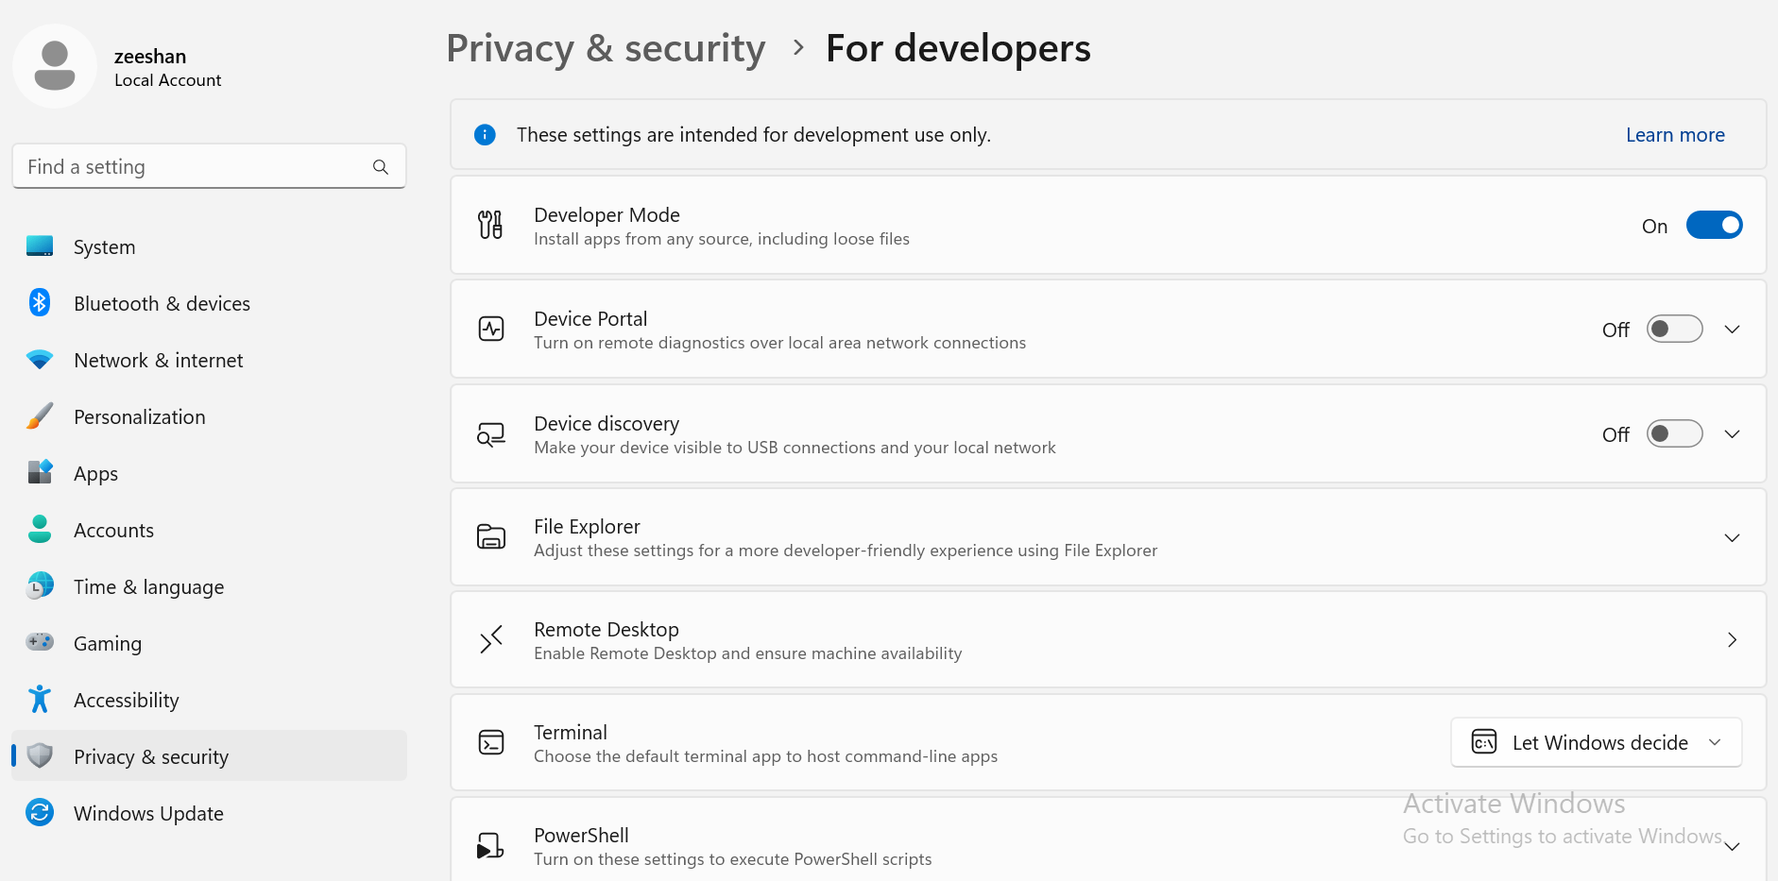

**Step 03: Go to settings and search Window features and click “Turn Windows features on or off”**

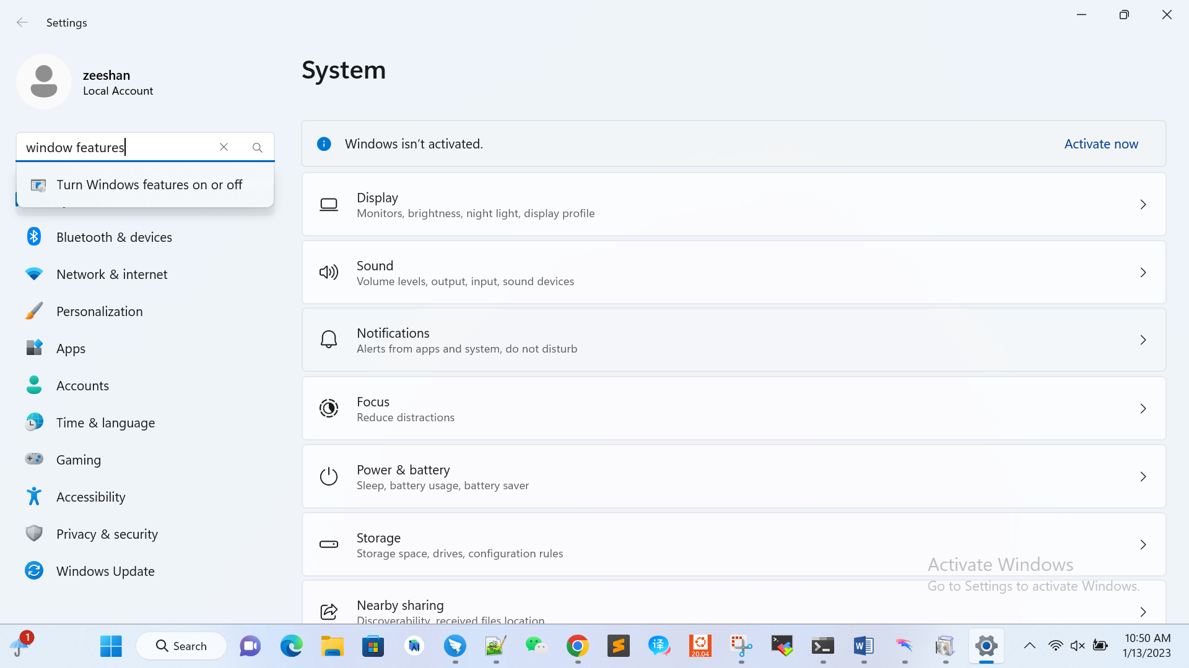

Check “Window Subsystem for Linux” and click OK.

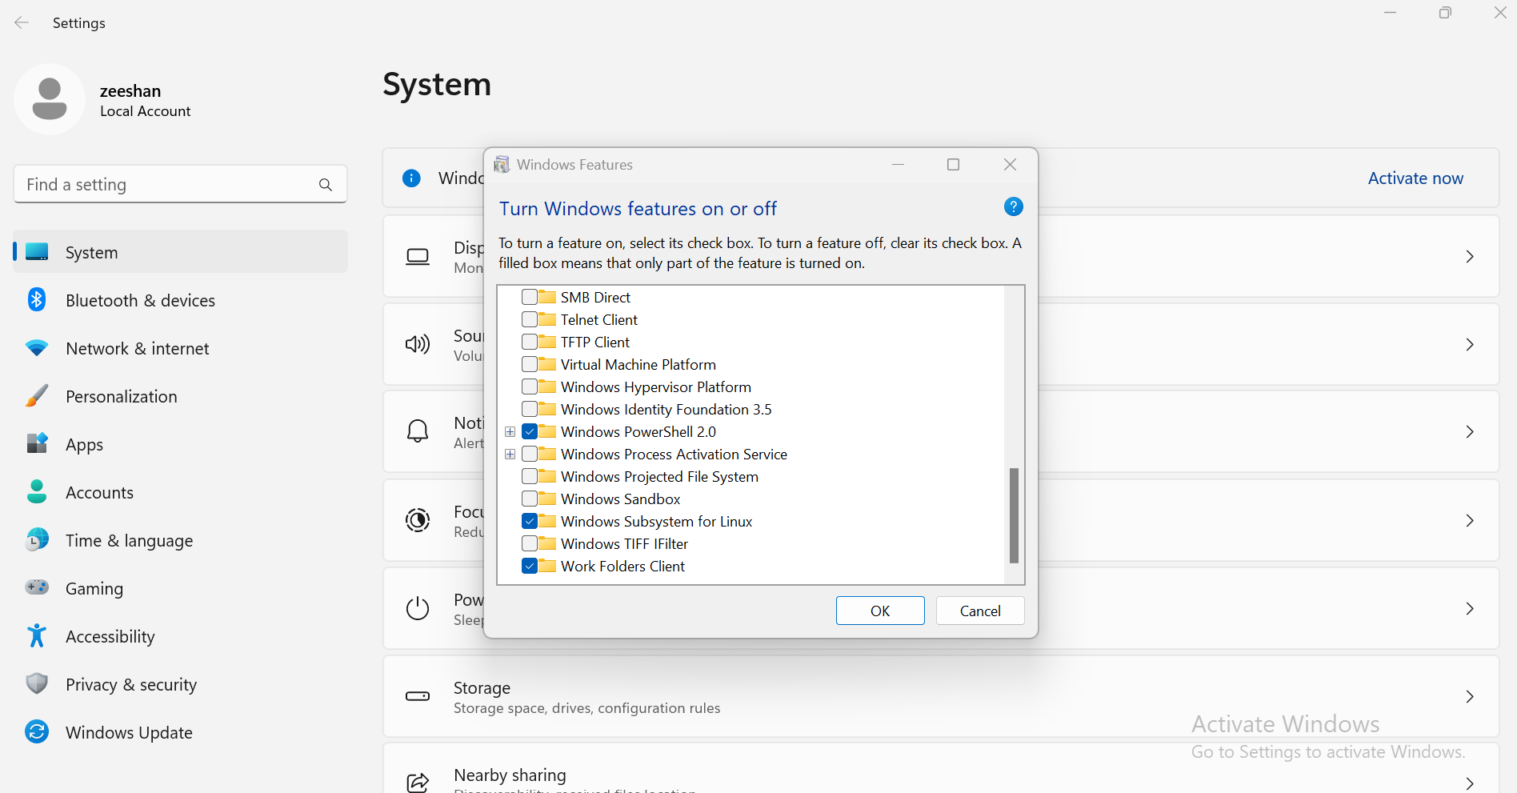

This operation will start enabling WSL on Windows:

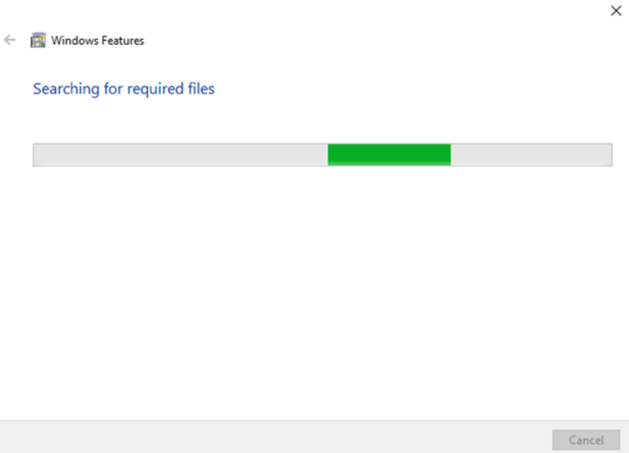

Then, restart the system to take effect of the changes by pressing the “**Restart now**” button:

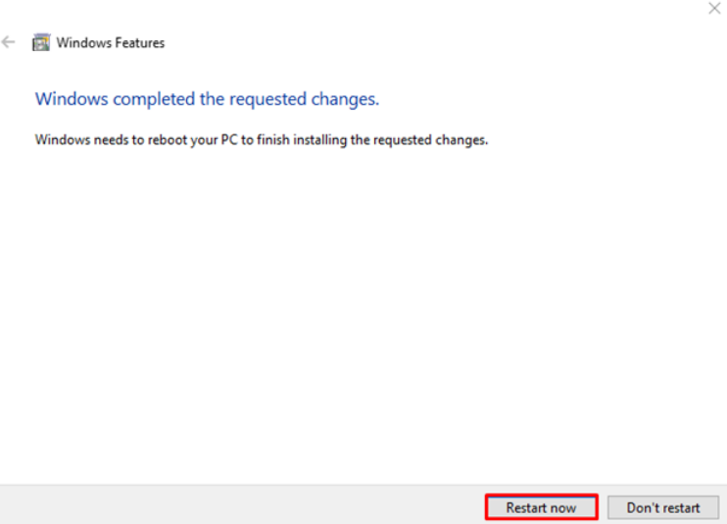

Now we have successfully enabled the WSL on Windows. We have to install Linux-supported tools that help us run Linux commands on Windows.

**Step 04: install Ubuntu Linux tool from “Microsoft Store**”**in windows:**

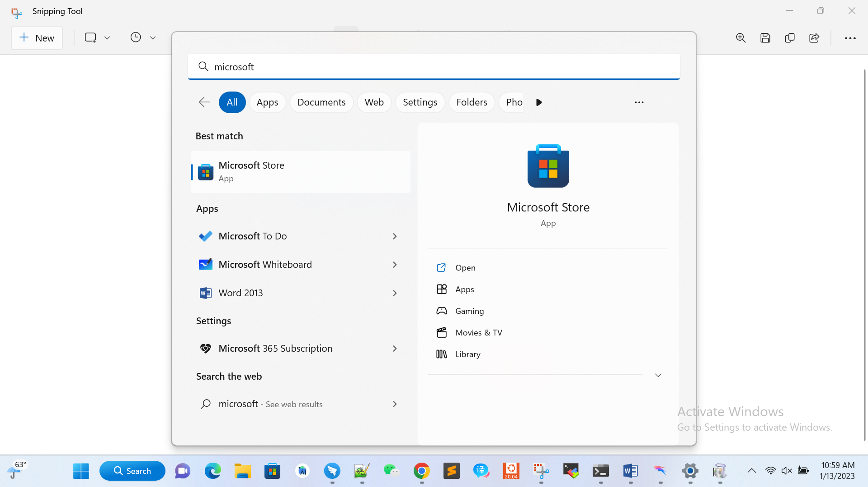

Search for “**Linux app**” in the search bar. Scroll down, select and open Ubuntu 22.04 LTS:

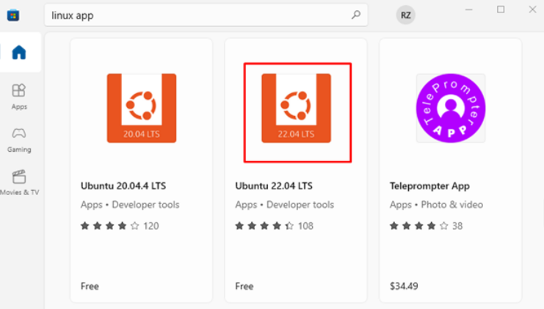

Click on the “**Get**” button to install Ubuntu 22.04 LTS terminal on Windows:

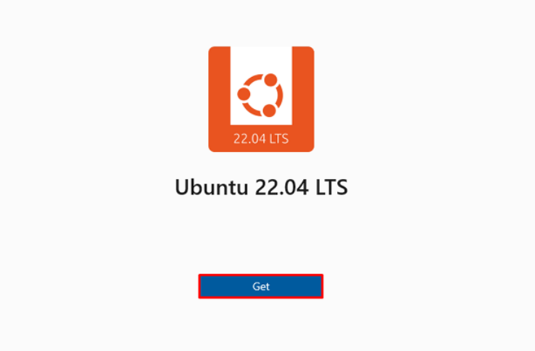

Press the “**Open**” button to open and configure Ubuntu 22.04 LTS on Windows:

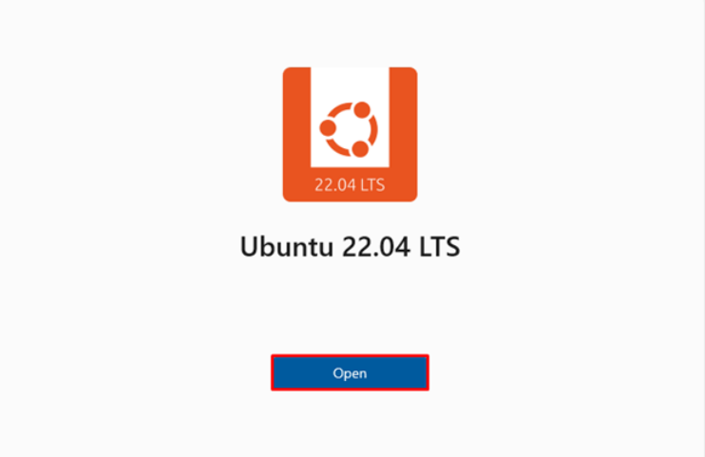

**Step 4: Setup Ubuntu’s Initial Settings**

The Ubuntu terminal will open on the screen. Set the username and password:

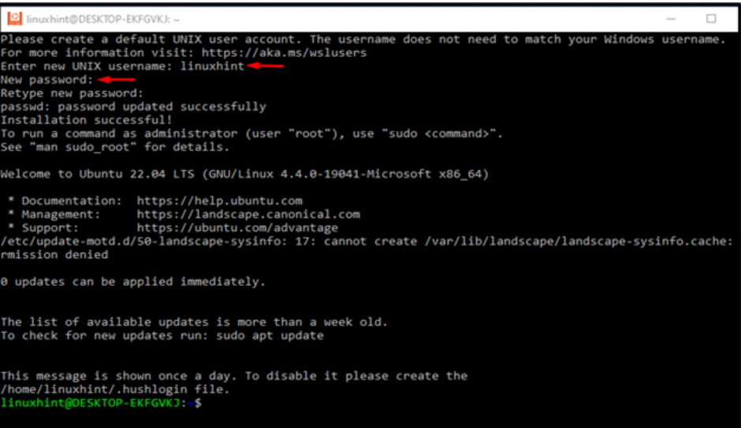

You have successfully installed “**Windows Subsystem for Linux**” (**WSL**)”

Now, to run the Linux prompt go to CMD and type bash:

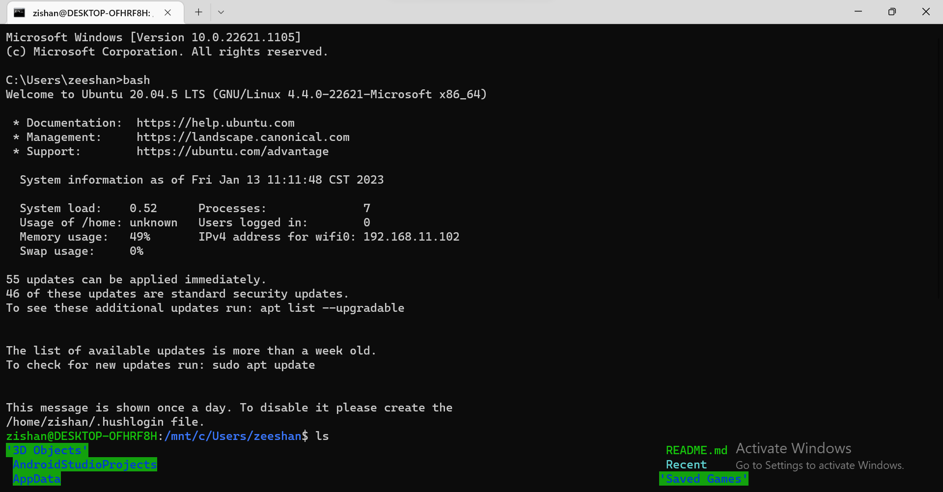

**How to create and run .sh file using bash command**

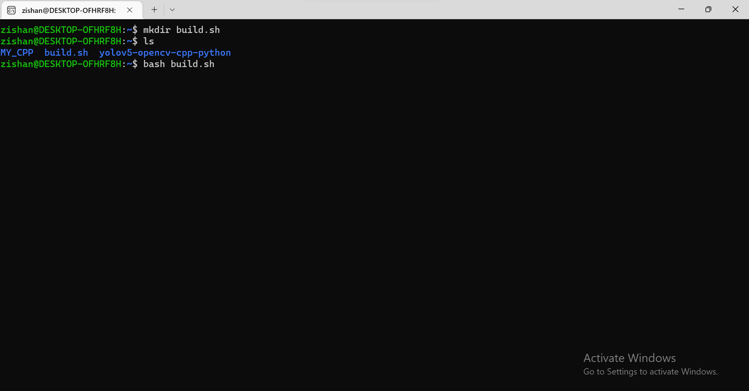

**Linux References:**

**[1]** [**https://linuxhint.com/run-sh-file-windows/**](https://linuxhint.com/run-sh-file-windows/)

**[2]** [**https://www.youtube.com/watch?v=i1ZroJzsw90&list=PLH4mzrKSvtSKWjMET-TVf85ZBMz_zvRGW**](https://www.youtube.com/watch?v=i1ZroJzsw90&list=PLH4mzrKSvtSKWjMET-TVf85ZBMz_zvRGW)

**[3]** [**https://www.cyberciti.biz/faq/howto-compile-and-run-c-cplusplus-code-in-linux/**](https://www.cyberciti.biz/faq/howto-compile-and-run-c-cplusplus-code-in-linux/)

**[4]** [**https://devconnected.com/how-to-copy-directory-on-linux/**](https://devconnected.com/how-to-copy-directory-on-linux/)